LISTA 11

Roberta Cristina de abreu 4°ADS

1)

**Criando os grupos:**

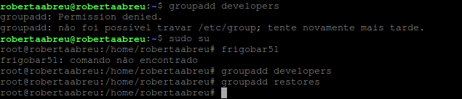

**Adicionando os usuários aos grupos:**

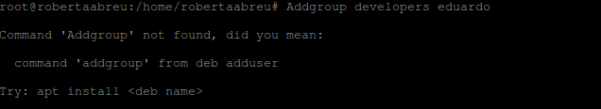

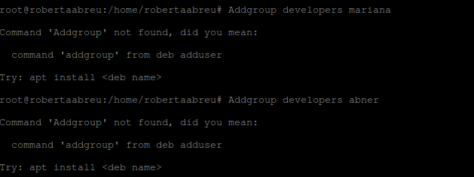

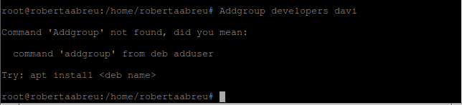

**Definindo os administradores dos grupos**

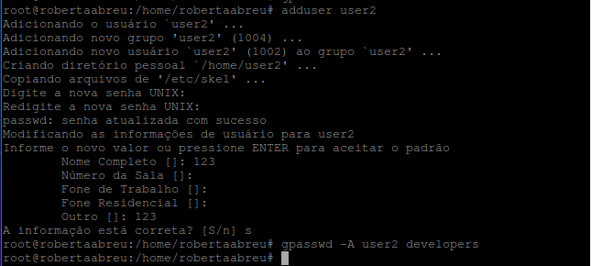





**Criando as pastas e alterando as permissões**

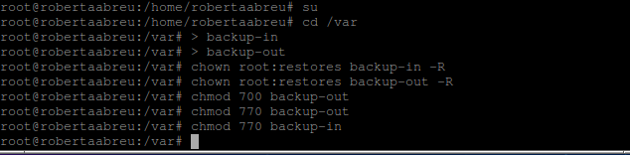

**Estabelecendo quota**

Nano /etc/fstab

quotacheck -acug /home

quotacheck –avug

edquota tome

edquota lamoni

**Criando o arquivo de backup com a rotina no crontab**

>backup.sh

nano backup.sh

#!/bin/bash

cd /var/backup-in

var=$(date +%Y-%m-%d)

tar -cvzf $var.tar.gz /var/backup-in

cp /var/ backup-in /$var.tar.gz /var/ backup-out /

root@debian:/# crontab -e

m h don mon dow command

*/1 * * * * sh /var/backup.sh

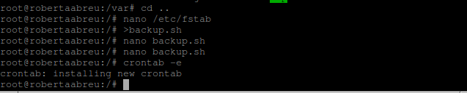

**History 11**

1 history

2 poweroff

3 cd ../..

4 ls

5 cd var

6 ls

7 mkdir d1

8 mkdir d2

9 mkdir d3

10 ls

11 cd d1

12 d1a.txt

13 >d1a.txt

14 >d1b.txt

15 >d1c.txt

16 cd ..

17 cd d2

18 >d2a.txt

19 >d2b.txt

20 >d2c.txt

21 cd ..

22 cd d3

23 >d3a.txt

24 >d3b.txt

25 >d3c.txt

26 ls

27 cd d2

28 cd ..

29 cd d2

30 ls

31 cd ..

32 cd d1

33 ls

34 cd ..

35 backup.sh

36 nano backup.sh

37 mkdir backp

38 nano backup.sh

39 sudo service ssh start

40 ifconfig

41 nano backup.sh

42 crontab -e

43 ls

44 cd ..

45 backup.sh

46 >backup.sh

47 nano backup.sh

48 crontab -e

49 ifconfig

50 history

51 history > history9.txt

52 cat /etc/passwd

53 su user1

54 exit

55 frigobar51

56 su user1

57 exit

58 cd /var

59 > backup-in

60 > backup-out

61 chown root:restores backup-in -R

62 chown root:restores backup-out -R

63 chmod 700 backup-out

64 chmod 770 backup-out

65 chmod 770 backup-in

66 ls -la

67 cd ..

68 nano /etc/fstab

69 >backup.sh

70 nano backup.sh

71 crontab -e

72 history > history11.txt